# Information sheet - Current Helicopters in Use

Helicopter types are up to date and the most frequently used, but this is subject to changes. Therefore this information is published separately on the NOGEPA website under ‘Downloads’.

The following aircraft types are currently in use in the Dutch Sector of the Southern North Sea:

* AW139
* AW189
* EC175
* S92

The following descriptions are for information only. For detailed specifications, operational and performance capabilities and flying guides, operators are to consult the manufacturers’ supporting documentation for each helicopter.

**1. AW139**

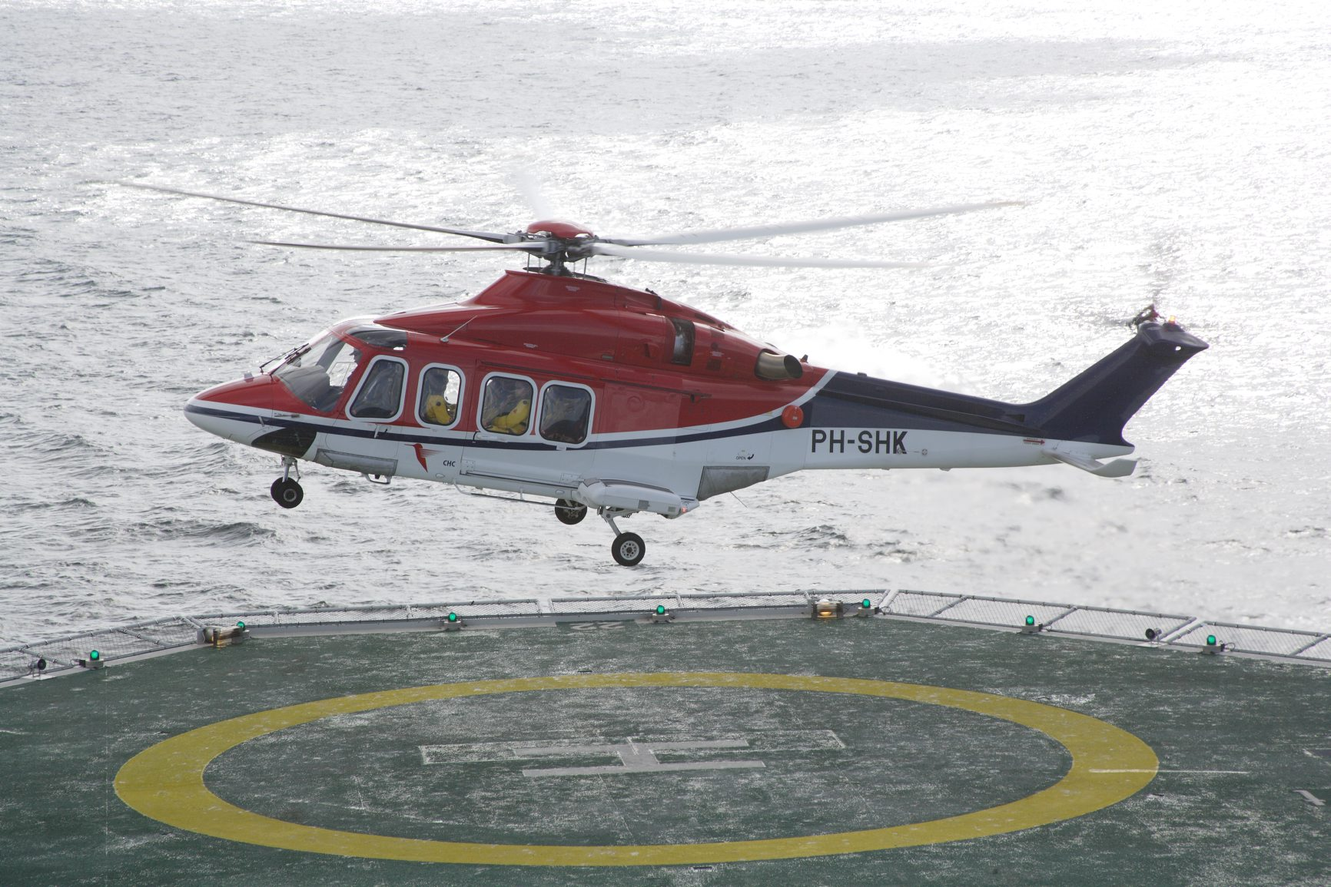The AW139 is a 12-seat medium-sized, multi-role, twin-engine helicopter developed and produced principally by Leonardo (formerly Augusta Westland). D-value is 17, which makes it capable of landing on almost any deck.

**1.1 General Data**

|  |  |
| --- | --- |
| MTOW | 6800 kg (6400 kg short nose) |
| Standard Fuel load | 1650 kg |
| Crew | 2 |
| Passengers | 12 |
| Speed (Cruise) | 167 Kts (135Kts) |
| Range | 550 NM |
| Service ceiling | 20.000 ft |
| Powerplant | 2 x Pratt & Whitney Canada PT6C |
| Cargo hold | 300 kg |

**1.2 Aircraft Dimensions**

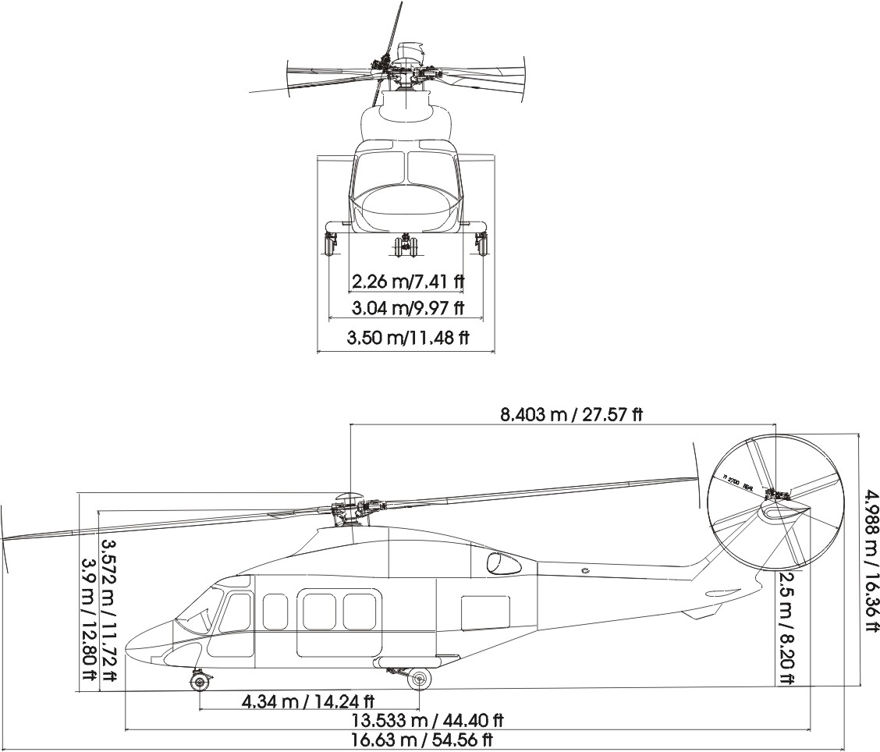

**1.3 Safe Approach Path**

The safe approach paths for embarking and disembarking the helicopter are as shown below.





**2. AW189**

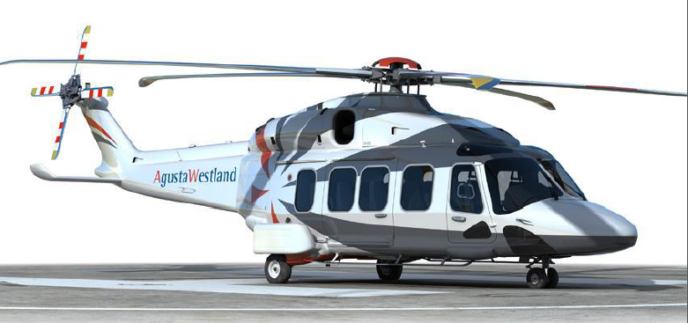

The AW189 is a 16-seat 8-ton class medium, twin-engine helicopter developed and produced by Leonardo (formerly Augusta Westland). D-value is 18.

**2.1 General Data**

|  |  |
| --- | --- |
| MTOW | 8600 kg |
| Standard Fuel load | 2050 kg |
| Crew | 2 |
| Passengers | 16 |
| Speed | 169 Kts |
| Range | 550 NM |
| Powerplant | 2x GE CT7-2E1 |
| Cargo hold | 460 kg |

**2.2 Aircraft Dimensions**

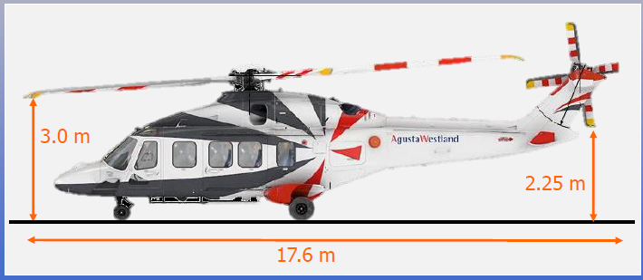

**2.3 Safe Approach Path**

The safe approach paths for embarking and disembarking the helicopter are as shown below.





**3. H175/EC175**

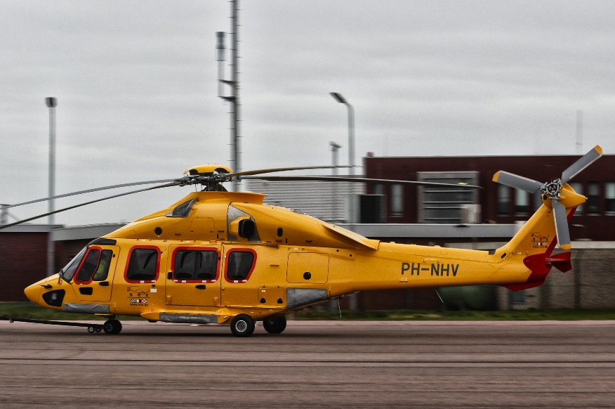

The Airbus Helicopters H175 is a 7-ton class medium utility helicopter produced by Airbus Helicopters (formerly Eurocopter Group).

**3.1 General Data**

|  |  |
| --- | --- |
| MTOW | 7500 Kg |
| Standard Fuel load | 2136 Kg |
| Crew | 2 |
| Passengers | 16 |
| Speed (Cruise) | 145 Kts |
| Range (normal configuration) | 589 NM |
| Endurance | 6 hrs |
| Service ceiling | 15000 |
| Powerplant | 2 P&WC PT6C-67E |

**3.2 Aircraft Dimensions**

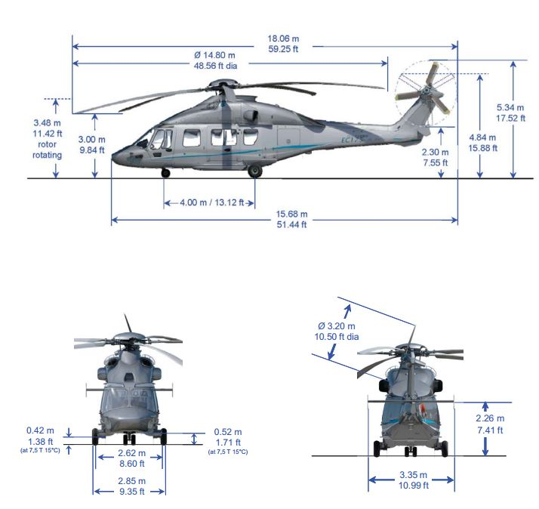

**3.3 Safe Approach Path**

The safe approach paths for embarking and disembarking the helicopter are shown below.

All movements are to be conducted under the direction of the HLO.

|  |
| --- |
| **WARNING** |
| **Ensure all personnel remain clear of the rotor disc area during engine start or rotor engagement. Rotor blades can dip causing fatal injury.** |

Alternative Approach

Normal Approach

**DANGER**

Never enter this area

Only enter this area with Pilot’s permission

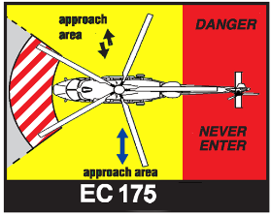

**4. S92**

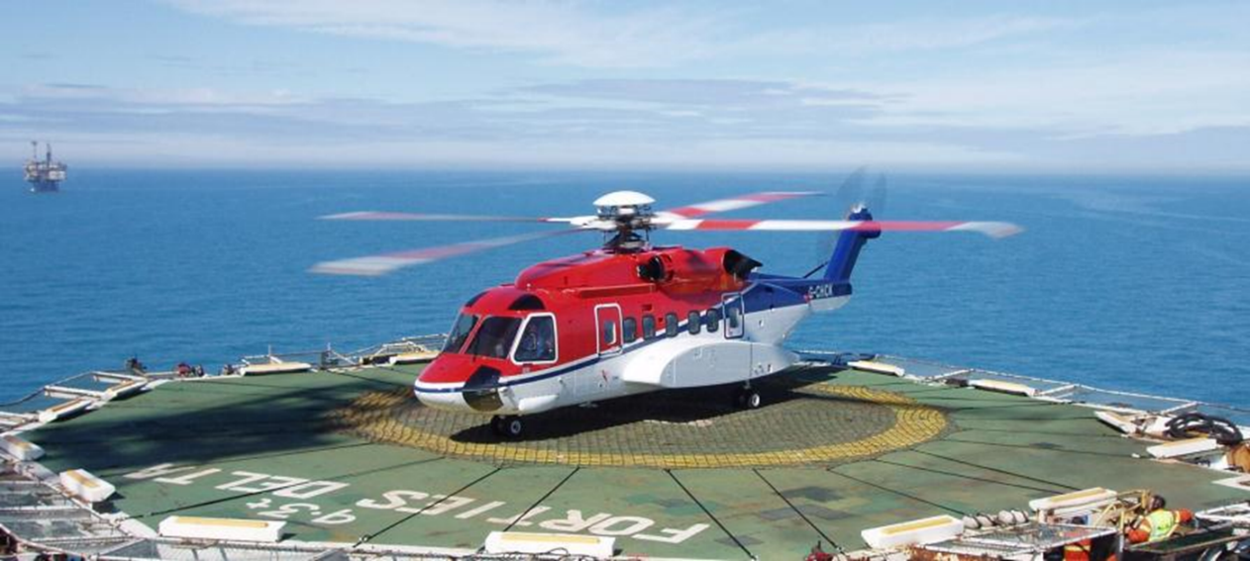

The Sikorsky S-92 is an American twin-engine medium-lift helicopter built by Sikorsky Aircraft for the civil and military helicopter markets.

**4.1 General Data**

|  |  |
| --- | --- |
| MTOW | 12020 Kg |
| Standard Fuel load | 2877 ltr |
| Crew | 2 |
| Passengers | 18 |
| Speed (Cruise) | 140 Kts |
| Range (30 mins reserve) | 458 NM |
| Endurance (30 mins reserve) | 3.2 hrs |
| Service ceiling | 14000 |
| Powerplant | 2 x General Electric CT7-8A |

**4.2 Aircraft Dimensions**

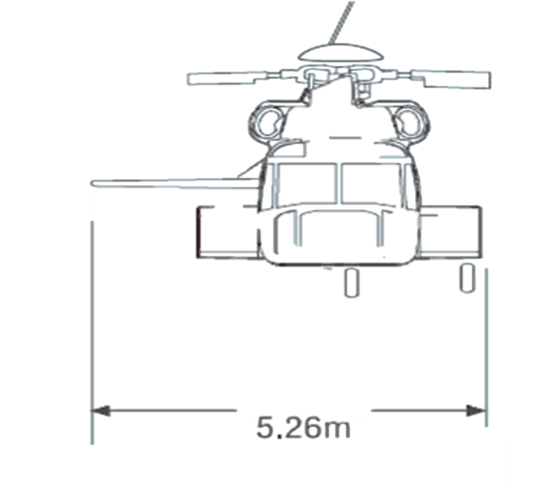

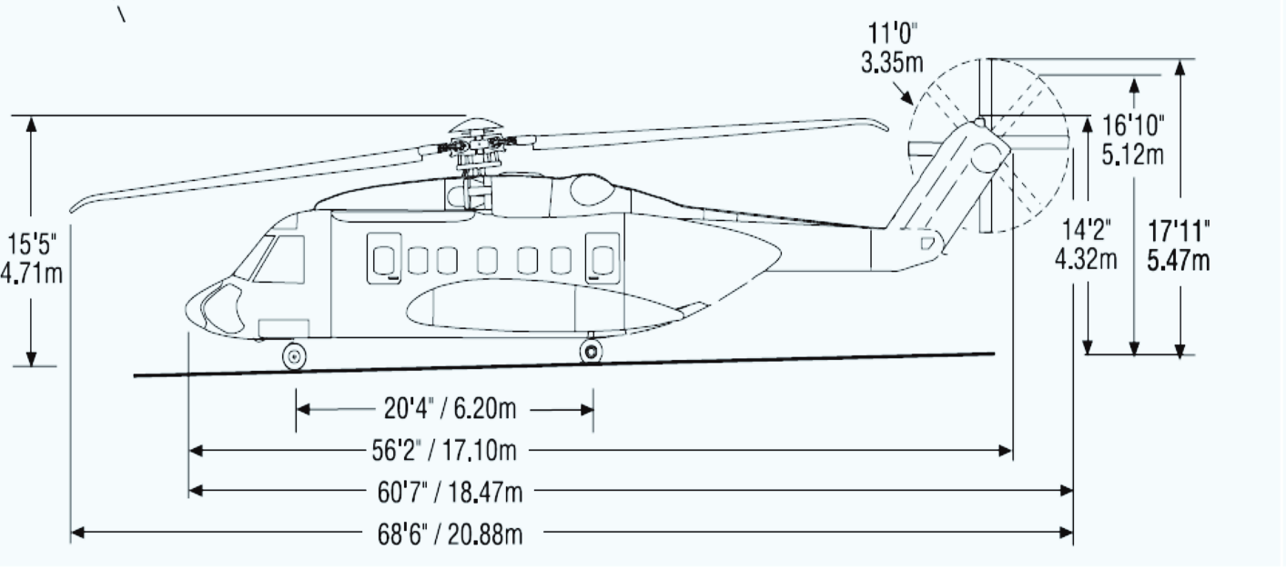

**4.3 Safe Approach Path**

The safe approach paths for embarking and disembarking the helicopter are shown below.

All movements are to be conducted under the direction of the HLO.

|  |
| --- |
| **WARNING** |
| **Ensure all personnel remain clear of the rotor disc area during engine start or rotor engagement. Rotor blades can dip causing fatal injury.** |

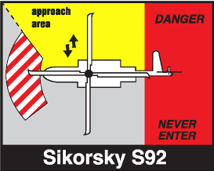

Normal Approach

**DANGER**

Never enter this area

Only enter this area with Pilot’s permission

# 